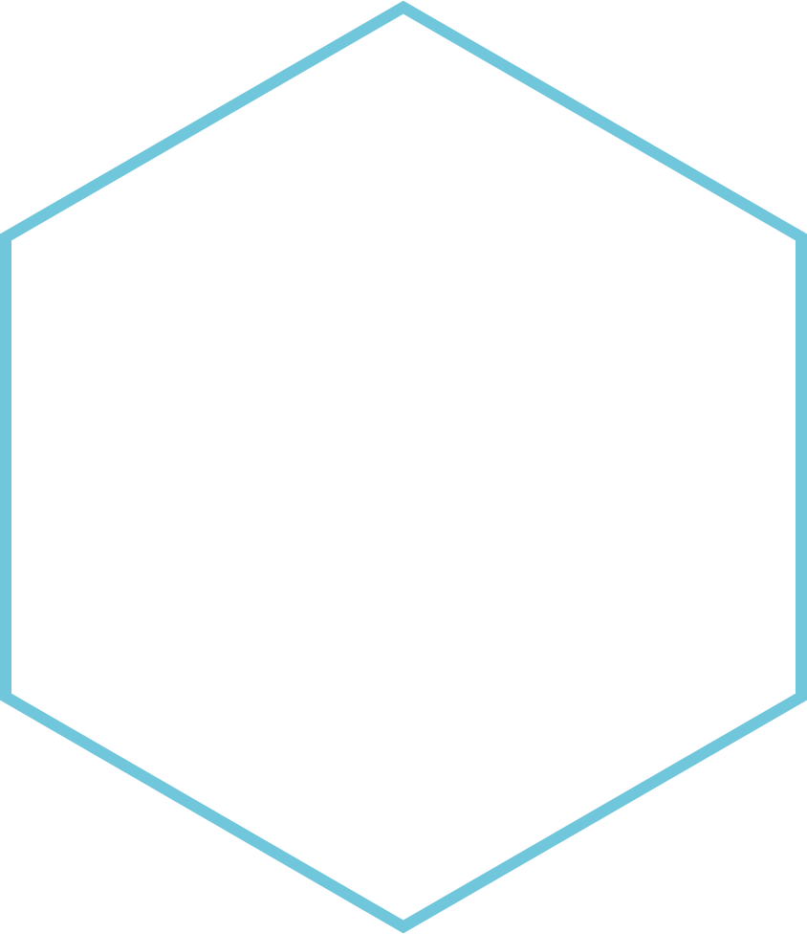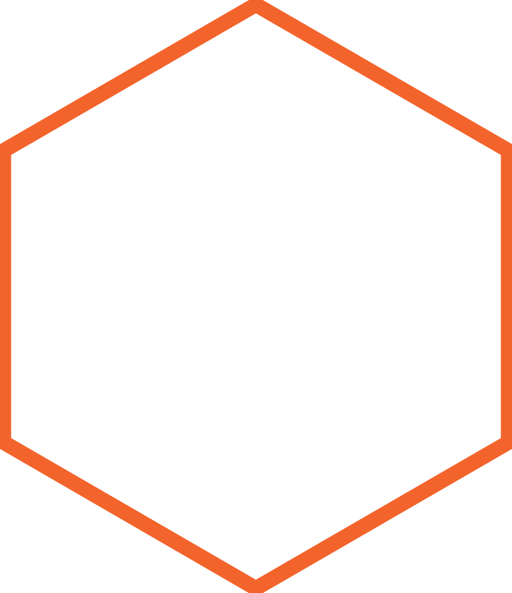

|  |
| --- |
| **COMPETEMCY DEMONSTRATION** |
| SITE SPECIFICATION DOCUMENT  Amel Hanifi – CIS 241 |
| This is a site specification document. It will showcase the work I have completed throughout this quarter. |
|  |





|  |  |  |
| --- | --- | --- |
| Project Description This is a site specification document for my personal Web site. My web site or Portfolio will enable me to showcase the work that I have completed throughout this quarter.  We have been asked to build this web site through a process and consisted of number of smaller projects, which will replicate the Web development life cycle and reinforce the knowledge we acquired in our earlier studies. My Page Design A soon as you get into the home Page you will see my biography on the right, and a picture of me on the right. In the header, there will be a link to all the pages that I have created, for an easy access. The webpages I have created are as follow:   * **The home** **Page: home.html**   Where I introduced myself and shared some personal information about my previous jobs and my interests.   * **My personal resume: resume.html**   The resume is built in tables. I specified what kind of job I am seeking, my skills and my education. I also added a brief employment history.   * **Interest Page:** **interest.html**   This page will display some of my interests, through 4 external links. I will share some of my interest such as music, traveling, cooking and reading. As soon as the user click a link, he will be prompted to another page outside of my website.  Competency Demonstration |  | **Screenshots Preview** • • • |
|  |
|  |
| * **A "mailto" guestbook form: guestbook.html**   This page is made specially for the visitors of my website. They will be asked to enter their names and email address, and will be asked couple questions related to their experience with web development and their interests. They will also provide some information about how they find my page, and can also leave a comment.   * **"Ah ha!" moment Page: reflections.html**   In this page I will share all the details I learned throughout this quarter.  All the exciting moment when trying new statement. I will add some images of my favorites results. |

# My Portfolio

# **Home Page - home.html**

# **My resume – resume.html**

# **My Interests – interest.html**

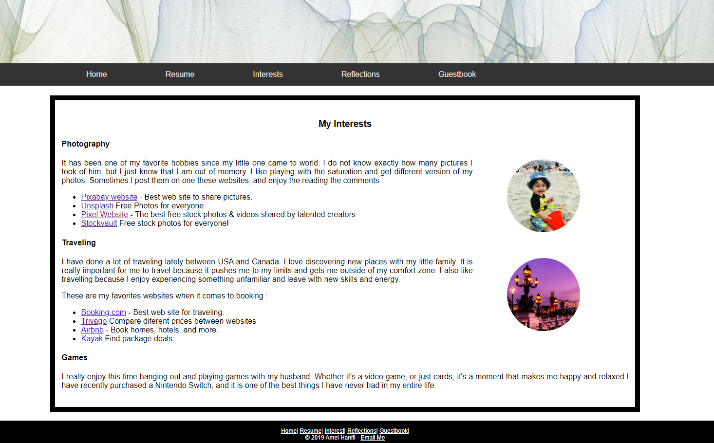

# **My “AH HA” Moments – Reflections.html**

# **My Guestbook Page – Guesbook.html**

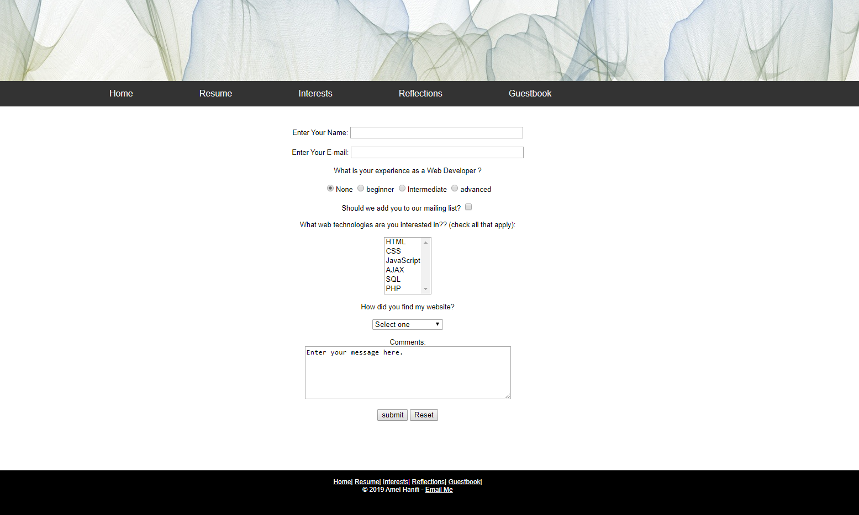

# Conclusion

I have developed this website only by using HTML and CSS. I am willing to take different other classes that has for goal to improve the layout and capabilities of websites in general, such as JavaScript and CMS. Other versions of this website will be available in the near future! stay tune!